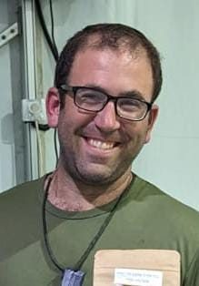 | BAYIT BRIGADE &  BEEF UP OUR BOYS  Honor the Life and Ultimate Contribution to Am Yisroel  Ari Yehiel Zenilman (z”l)
On Erev Sukkot, Ari and Chava welcomed their third child. Since Sukkot celebrates water through the Simchat Beit Hashoeva, they named their daughter Maayan. On the following Shabbat, Ari said goodbye to his wife and three children, grabbed his gear and joined his reserve army unit in the south. Ari, who made aliya in 2005, served in the army after high school, studied at Yeshivat Har Etzion, and earned a BS in PPE from Hebrew University. He worked at Mobileye as an Algorithm Data Analyst.
Despite a busy life, Ari balanced work, family, Torah learning, and hobbies. Tragically, he was killed in battle on December 10, leaving behind his wife, three young children, and grieving family and friends.
There is a fund to assist the Zenilman family, may they be comforted and strengthened.
Ari's family selected the verse on the sticker below, which will adorn 2000 Beef Jerky packages. At Beef UP Our Boys, we share a close bond with Ari and his unit—among our first recipients. Their feedback, in the form of amazing pictures and appreciation, has propelled the distribution of over 32,000 free packages. We are honoured to support those who give everything, and the Zenilman family is now part of the foundation that will forever strengthen our nation.
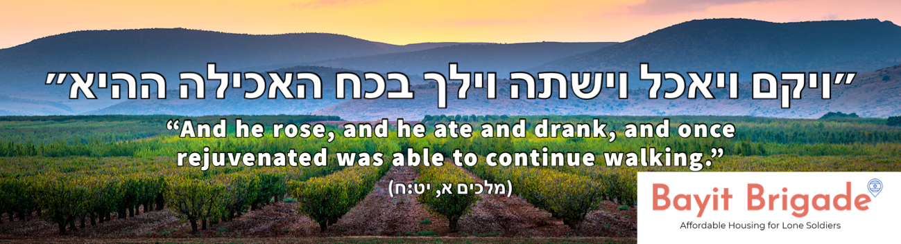
Photo and Graphics by YA FINE ART

